

| **Title:** Implement contrast stretching of a digital image. |
| --- |

**Objective:** To learn & understand contrast stretching.

**Expected Outcome of Experiment:**

| **CO** | **Outcome** |
| --- | --- |
| **CO4** | Design & implement algorithms for digital image enhancement, segmentation & restoration. |

**Books/ Journals/ Websites referred:**

1. http://www.mathworks.com/support/
2. www.math.mtu.edu/~msgocken/intro/intro.html.
3. R. C.Gonsales R.E.Woods, “Digital Image Processing”, Second edition, Pearson Education
4. S.Jayaraman, S Esakkirajan, T Veerakumar “Digital Image Processing “Mc Graw Hill.
5. S.Sridhar,”Digital Image processing”, oxford university press, 1st edition."

**Pre Lab/ Prior Concepts:**

Contrast stretching (often called normalization) is a simple image enhancement technique that attempts to improve the contrast in an image by `stretching' the range of intensity values it contains to span a desired range of values, *e.g.* the the full range of pixel values that the image type concerned allows. It differs from the more sophisticated histogram equalization in that it can only apply a *linear* scaling function to the image pixel values. As a result the ‘enhancement’ is less harsh.

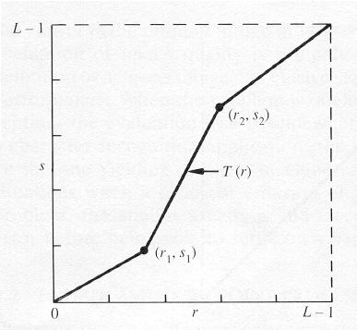

The locations of (r1,s1) and (r2,s2) control the shape of the transformation function.

* If r1= s1 and r2= s2 the transformation is a linear function and produces no changes.
* If r1=r2, s1=0 and s2=L-1, the transformation becomes a thresholding function that creates a binary image.
* Intermediate values of (r1,s1) and (r2,s2) produce various degrees of spread in the gray levels of the output image, thus affecting its contrast.

Generally, r1≤r2 and s1≤s2 is assumed.

**Implementation steps with screenshots:**

**CODE:**

**clc; clear; close all;**

**filename = input('Enter the image filename (with extension): ', 's');**

**img = imread(filename);**

**gray_img = rgb2gray(img);**

**r1 = input('Enter r1: ');**

**s1 = input('Enter s1: ');**

**r2 = input('Enter r2: ');**

**s2 = input('Enter s2: ');**

**stretched_img = contrastStretch(gray_img, r1, s1, r2, s2);**

**figure;**

**subplot(2,2,1), imshow(gray_img), title('Original Image');**

**subplot(2,2,2), imshow(stretched_img), title('Contrast Stretched Image');**

**subplot(2,2,3), imhist(gray_img), title('Histogram of Original Image');**

**subplot(2,2,4), imhist(stretched_img), title('Histogram of Stretched Image');**

**function output = contrastStretch(img, r1, s1, r2, s2)**

**img = double(img);**

**L = 256;**

**output = zeros(size(img));**

**for i = 1:size(img,1)**

**for j = 1:size(img,2)**

**r = img(i,j);**

**if r < r1**

**output(i,j) = (s1/r1) * r;**

**elseif r1 <= r && r <= r2**

**output(i,j) = ((s2 - s1) / (r2 - r1)) * (r - r1) + s1;**

**else**

**output(i,j) = ((L-1 - s2) / (L-1 - r2)) * (r - r2) + s2;**

**end**

**end**

**end**

**output = uint8(output);**

**end**

**OUTPUT:**

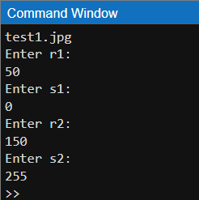

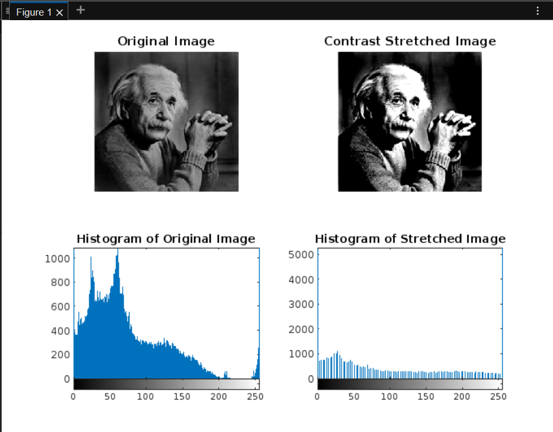

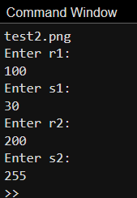

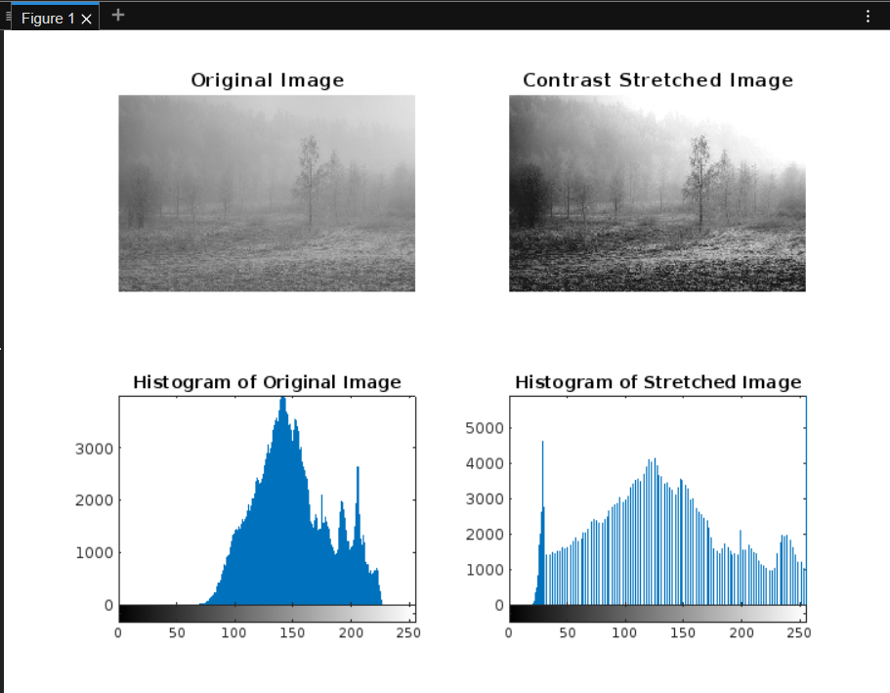

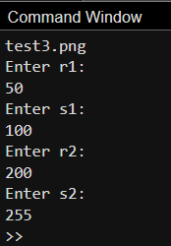

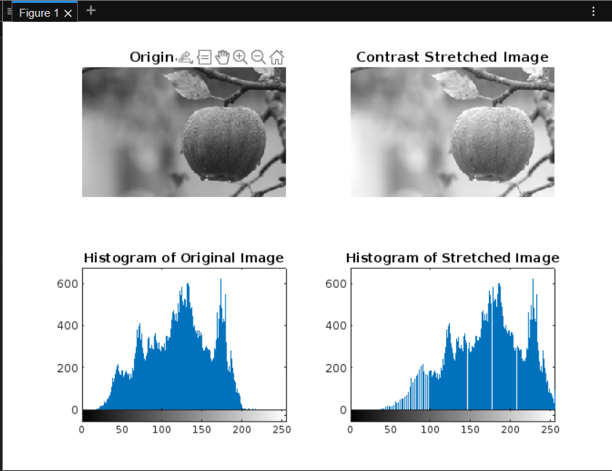

**Conclusion:**

Contrast stretching enhances image quality by adjusting pixel intensity distribution, improving visibility. This experiment demonstrates effective digital image enhancement techniques for better segmentation and restoration.

**Date: 27-02-2025 Signature of faculty in-charge**

**Post Lab Descriptive Questions**

1. Thresholding function in contrast stretching creates
2. binary image
3. high quality image
4. enhanced image
5. low quality image
6. When is the contrast stretching transformation a linear function, for r and s as gray-value of image before and after processing respectively?

a) r1 = s1 and r2 = s2

b) r1 = r2, s1 = 0 and s2 = L – 1, L is the max gray value allowed

c) r1 = 1 and r2 = 0

d) None of the mentioned

3. Which gray-level transformation increases the dynamic range of gray-level in the image?

a) Power-law transformations

b) Negative transformations

c) Contrast stretching

d) None of the mentioned

4. When is the contrast stretching transformation a thresholding function, for r and s as gray-value of image before and after processing respectively?

a) r1 = s1 and r2 = s2

b) r1 = r2, s1 = 0 and s2 = L – 1, L is the max gray value allowed

c) r1 = 1 and r2 = 0

d) None of the mentioned

5. What condition prevents the intensity artifacts to be created while processing with contrast stretching, if r and s are gray-values of image before and after processing respectively?

a) r1 = s1 and r2 = s2

b) r1 = r2, s1 = 0 and s2 = L – 1, L is the max gray value allowed

c) r1 = 1 and r2 = 0

d) r1 ≤ r2 and s1 ≤ s2